**Complete Queries for Implementing the Complete Company Database**

Implementing the Complete Company Database Creating the tables.

**SQL STATEMENT TO CREATE EMPLOYEE TABLE**

CREATE TABLE employee ( Fname varchar (15) NOT NULL, Minit varchar(1), Lname varchar(15) NOT NULL, SSN varchar(9) NOT NULL, Bdate date, Address varchar(30), Sex varchar(1), Salary float, Super_ssn varchar(9), Dno int NOT NULL, PRIMARY KEY (ssn), FOREIGN KEY (Super_ssn) REFERENCES employee(ssn));

**SQL STATEMENT TO CREATE DEPARTMENT TABLE**

CREATE TABLE department (Dname varchar(15) NOT NULL, Dnumber int NOT NULL, Mgr_ssn varchar(9) NOT NULL, Mgr_start_date date, PRIMARY KEY (Dnumber), UNIQUE(Dname), FOREIGN KEY (Mgr_ssn) REFERENCES employee(ssn));

**SQL STATEMENT TO CREATE DEPT_LOCATIONS TABLE**

CREATE TABLE dept_locations (Dnumber int NOT NULL, Dlocation varchar(15), PRIMARY KEY (Dnumber, Dlocation), FOREIGN KEY (Dnumber) REFERENCES department (Dnumber));

**SQL STATEMENT TO CREATE PROJECT TABLE**

CREATE TABLE project (Pname varchar(15) NOT NULL, Pnumber int NOT NULL, Plocation varchar(15), Dnum int NOT NULL, PRIMARY KEY (Pnumber), UNIQUE (Pname), FOREIGN KEY (Dnum) REFERENCES department (Dnumber));

**SQL STATEMENT TO CREATE WORKS_ON TABLE**

CREATE TABLE works_on (Essn varchar(9) NOT NULL, Pno int NOT NULL, Hours float NOT NULL, PRIMARY KEY (Essn, Pno), FOREIGN KEY (Essn) REFERENCES employee(ssn), FOREIGN KEY (Pno) REFERENCES project(Pnumber));

**SQL STATEMENT TO CREATE DEPENDENT TABLE**

CREATE TABLE dependent (Essn varchar(9) NOT NULL, Dependent_name varchar(15) NOT NULL, Sex varchar(1), Bdate date, Relationship varchar(8), PRIMARY KEY (Essn, Dependent_name), FOREIGN KEY (Essn) REFERENCES employee(ssn));

Implementing the Complete Company Database Inserting values into the tables.

**SQL STATEMENT FOR INSERTING VALUES INTO EMPLOYEE TABLE**

INSERT INTO employee (Fname, Minit, Lname, SSN, Bdate, Address, Sex, Salary, Super_ssn, Dno) values (‘James’, ‘E’, ‘Borg’, 888665555, ’10-NOV-1937′, ‘430 Stone, Houston, TX’, ‘M’, 55000, NULL, 1);  
INSERT INTO employee (Fname, Minit, Lname, SSN, Bdate, Address, Sex, Salary, Super_ssn, Dno) values (‘Jennifer’, ‘S’, ‘Wallace’, 987654321, ’20-JUN-1941′, ‘291 Berry, Bellaire, TX’, ‘F’,43000, 888665555, 4);  
INSERT INTO employee (Fname, Minit, Lname, SSN, Bdate, Address, Sex, Salary, Super_ssn, Dno) values (‘Franklin’, ‘B’, ‘Wong’, 333445555, ’08-DEC-1955′, ‘638 Voss, Houston, TX’, ‘M’, 40000, 888665555, 5);  
INSERT INTO employee (Fname, Minit, Lname, SSN, Bdate, Address, Sex, Salary, Super_ssn, Dno) values (‘Alicia’, ‘J’, ‘Zelaya’, 999887777, ’19-JAN-1968′, ‘3321 Castle, Spring, TX’, ‘F’, 25000, 987654321, 4);  
INSERT INTO employee (Fname, Minit, Lname, SSN, Bdate, Address, Sex, Salary, Super_ssn, Dno) values (‘Ramesh’, ‘K’, ‘Narayan’, 666884444, ’15-SEP-1962′, ‘975 Fire Oak, Humble, TX’, ‘M’, 38000, 333445555, 5);  
INSERT INTO employee (Fname, Minit, Lname, SSN, Bdate, Address, Sex, Salary, Super_ssn, Dno) values (‘Joyce’, ‘A’, ‘English’, 453453453, ’31-JUL-1972′, ‘5631 Rice, Houston, TX’, ‘F’, 25000, 333445555, 5);  
INSERT INTO employee (Fname, Minit, Lname, SSN, Bdate, Address, Sex, Salary, Super_ssn, Dno) values (‘Ahmad’, ‘V’, ‘Jabbar’, 987987987, ’29-MAR-1969′, ‘980 Dallas, Houston, TX’, ‘M’, 25000, 987654321, 4);  
INSERT INTO employee (Fname, Minit, Lname, SSN, Bdate, Address, Sex, Salary, Super_ssn, Dno) values (‘John’, ‘B’, ‘Smith’, 123456789, ’09-JAN-1965′, ‘731 Fondren, Houston, TX’, ‘M’, 30000, 333445555, 5);

**SQL STATEMENT FOR INSERTING VALUES INTO EMPLOYEE TABLE**

INSERT INTO department (Dname, Dnumber, Mgr_ssn, Mgr_start_date) values (‘Research’, 5, 333445555, ’22-MAY-1988′);  
INSERT INTO department (Dname, Dnumber, Mgr_ssn, Mgr_start_date) values (‘Administration’, 4, 987654321, ’01-JAN-1995′);  
INSERT INTO department (Dname, Dnumber, Mgr_ssn, Mgr_start_date) values (‘Headquaters’, 1, 888665555, ’19-JUN-1981′);

**SQL STATEMENT FOR ALTERING EMPLOYEE TABLE TO ADD FOREIGN KEY CONSTRAINT**

ALTER TABLE employee ADD CONSTRAINT FK_Manages FOREIGN KEY (Dno) REFERENCES department (Dnumber);

**SQL STATEMENT FOR INSERTING VALUES INTO DEPT_LOCATIONS TABLE**

INSERT INTO dept_locations (Dnumber, Dlocation) values (1, ‘Houston’);  
INSERT INTO dept_locations (Dnumber, Dlocation) values (4, ‘Stafford’);  
INSERT INTO dept_locations (Dnumber, Dlocation) values (5, ‘Bellaire’);  
INSERT INTO dept_locations (Dnumber, Dlocation) values (5, ‘Sugarland’);  
INSERT INTO dept_locations (Dnumber, Dlocation) values (4, ‘Houston’);

**SQL STATEMENT FOR INSERTING VALUES IN TO PROJECT TABLE**

INSERT INTO project (Pname, Pnumber, Plocation, Dnum) values (‘ProductX’, 1, ‘Bellaire’, 5);  
INSERT INTO project (Pname, Pnumber, Plocation, Dnum) values (‘ProductY’, 2, ‘Sugarland’, 5);  
INSERT INTO project (Pname, Pnumber, Plocation, Dnum) values (‘ProductZ’, 3, ‘Houston’, 5);  
INSERT INTO project (Pname, Pnumber, Plocation, Dnum) values (‘Computerization’, 10, ‘Stafford’, 4);  
INSERT INTO project (Pname, Pnumber, Plocation, Dnum) values (‘Reorganization’, 20, ‘Houston’, 1);  
INSERT INTO project (Pname, Pnumber, Plocation, Dnum) values (‘Newbenfits’, 30, ‘Stafford’, 4);

**SQL STATEMENT FOR INSERTING VALUES INTO WORKS_ON TABLE**

INSERT INTO works_on (Essn, Pno, Hours) values (123456789, 1, 32.5);  
INSERT INTO works_on (Essn, Pno, Hours) values (123456789, 2, 7.5);  
INSERT INTO works_on (Essn, Pno, Hours) values (666884444, 3, 40.0);  
INSERT INTO works_on (Essn, Pno, Hours) values (453453453, 1, 20.0);  
INSERT INTO works_on (Essn, Pno, Hours) values (453453453, 2, 20.0);  
INSERT INTO works_on (Essn, Pno, Hours) values (333445555, 2, 10.0);  
INSERT INTO works_on (Essn, Pno, Hours) values (333445555, 3, 10.0);  
INSERT INTO works_on (Essn, Pno, Hours) values (333445555, 10, 10.0);  
INSERT INTO works_on (Essn, Pno, Hours) values (333445555, 20, 10.0);  
INSERT INTO works_on (Essn, Pno, Hours) values (999887777, 30, 30.0);  
INSERT INTO works_on (Essn, Pno, Hours) values (999887777, 10, 10.0);  
INSERT INTO works_on (Essn, Pno, Hours) values (987987987, 10, 35.0);  
INSERT INTO works_on (Essn, Pno, Hours) values (987987987, 30, 5.0);  
INSERT INTO works_on (Essn, Pno, Hours) values (987654321, 30, 20.0);  
INSERT INTO works_on (Essn, Pno, Hours) values (987654321, 20, 15.0);  
INSERT INTO works_on (Essn, Pno, Hours) values (888665555, 20, 0.0);

**SQL STATEMENT FOR INSERTING VALUES INTO DEPENDENT TABLE**

INSERT INTO dependent (Essn, Dependent_name, Sex, Bdate, Relationship) values (333445555, ‘Alice’, ‘F’, ’05-APR-1986′, ‘Daughter’);  
INSERT INTO dependent (Essn, Dependent_name, Sex, Bdate, Relationship) values (333445555, ‘Theodore’, ‘M’, ’25-OCT-1983′, ‘Son’);  
INSERT INTO dependent (Essn, Dependent_name, Sex, Bdate, Relationship) values (333445555, ‘Joy’, ‘F’, ’03-MAY-1958′, ‘Spouse’);  
INSERT INTO dependent (Essn, Dependent_name, Sex, Bdate, Relationship) values (987654321, ‘Abner’, ‘M’, ’28-FEB-1942′, ‘Spouse’);  
INSERT INTO dependent (Essn, Dependent_name, Sex, Bdate, Relationship) values (123456789, ‘Michael’, ‘M’, ’04-JAN-1988′, ‘Son’);  
INSERT INTO dependent (Essn, Dependent_name, Sex, Bdate, Relationship) values (123456789, ‘Alice’, ‘F’, ’30-DEC-1988′, ‘Daughter’);  
INSERT INTO dependent (Essn, Dependent_name, Sex, Bdate, Relationship) values (123456789, ‘Elizabeth’, ‘F’, ’05-MAY-1967′, ‘Spouse’);

**Company Database After Creating and Inserting the values into the database**

The image below is the Company Database After Creating and Inserting the values into the database.

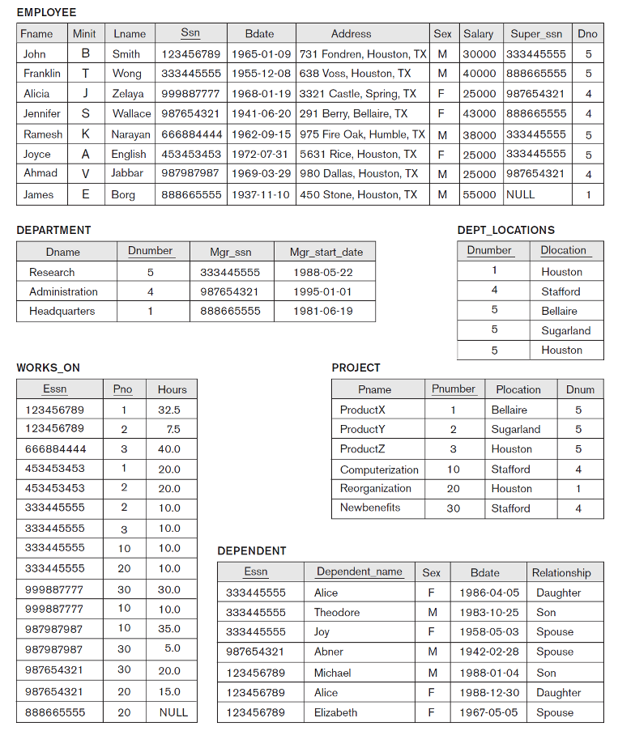Implementing the Complete Company Database 2